**ON-CAMPUS DELIVERY ROBOT**

by

**Muhannad Saeed AlGhamdi 1846525**

**Sulaiman Abdullah Abbas 1845862**

**Wael Rabah AlDhaheri 1846987**

**TEAM NO.: 03 FALL-2021 INTAKE**

Project Advisor

**Dr.mohammed bilal**

**Checked and approved (ADVISOR): _______________________**

Project Co-advisor: **None**

Project Customer: **Dr.mohammed bilal**

SDP Evaluator: **________________________________**

**Department of Electrical and Computer Engineering**

**Faculty of Engineering**

**King Abdulaziz University**

**Jeddah – Saudi Arabia**

**NOV. 2021 G – RABI’ II 1443 H**

# ABSTRACT

**ON-CAMPUS DELIVERY ROBOT**

The abstract should contain several paragraphs highlighting your report main topics. It may contain relevant short background, short summary about the situation description, short version of problem definition, project higher level objectives, alternative solutions, the optimum chosen solution, and description of baseline design. Note that, every item shall be described in a maximum of one paragraph (max of 5 sentences) that is very condensed and right to the point. The whole abstract must not fill more than this page without needing to change the page margins.

***Index Terms***— e.g. Radar Remote Sensing, Auto-Steering Systems, Power Control Electronics, Electric Wheelchair, Electric Motor Control, Distance Detection.

**Table of Content**

ABSTRACT ii

Table of Content iii

List of Figures iv

Chapter – 1 Introduction 6

1.1 About the project 6

1.2 Background 6

Chapter – 2 CONCEPTUAL DESIGN 7

2.1 situation description 7

2.2 Defining the Problem 7

2.3 PROJECT OBJECTIVES 7

2.4 APPLICABLE ENGINEERING STANDARDS 8

2.5 REALISTIC CONSTRAINTS 8

2.6 ProDuct Design Specifications (PDS) 8

2.7 Literature Review 8

2.8 THEORETICAL BACKGROUND AND ANALYSIS 9

2.9 Analyzing Alternative SOLUTIONs 9

2.10 maturing baseline design 10

Chapter – 3 PRODUCT BASELINE DESIGN 111

3.1 Block diagram 111

3.2 System descritpion 11

3.2.1 Circuit schematics 12

3.2.2 Circuit component specifications 12

3.2.3 Flowcharts for software blocks 12

3.2.4 Mechanical specifications of the case 12

3.2.5 Possible aesthetics 12

3.2.6 Input/output specifications 12

3.2.7 Operating Instructions 12

3.3 Simulation results 12

Chapter – 4 Preliminary Evaluation of Baseline design 13

4.1 Technical Aspects 13

4.2 Cost Analysis 13

4.3 Environmental impact 13

4.4 impact on society 14

4.5 Global Impact 14

References 15

**List of Figures**

Fig. 1 A handicapped with helper, stick and wheelchair……………...…..…………2

Fig. 2 The Duncker diagram……………………………..………………..……………8

Fig. 3 Wheelchair dimensions...………………………………………….……………12

Fig. 4 Various themes of electric wheelchair…………………………..…………….13

Fig. 5 Automatic steering system general block diagram…….…….………………14

Fig. 6 Automatic steering system functional block diagram………..………………14

Fig. 7 Gantt chart of the project…………………………………….…………………16

Fig. 8 Block diagram of the RF oscillator………………………….…………………18

Fig. 9 RF oscillator circuit..………………………………………….…………………19

Fig. 10 FFT of the simulated oscillator…………………………….…………………20

Fig. 11 Double layer of Darlington network buffer amplifier….….…………………21

Fig. 13 Receiver buffer amplifier circuit……………..………………………….…….25

Fig. 14 IR sensor surrounded by a black rubber cylinder to prevent outside unwanted reflection and insures narrow beam reception…….……………………..26

Fig. 15 Phase correlator circuit………………………………..………………………27

Fig. 16 Bode diagram of the low-pass filter of phase correlator…………………...27

Fig. 17 Scaling amplifier Op Amp circuit…………………………………………......28

Fig. 18 Controlling the direction of one wheel using a microcontroller………...…29

Fig. 19 Motor speed control using voltage divider (one direction)………………...30

Fig. 20 Bidirectional dc motor drive (h-bridge) circuit……………………………....31

Fig. 21 Full-bridge forward current flow diagram……………………………………33

Fig. 22 12Vdc to 120Vac inverter……………………………………………………..35

Fig. 23 Final circuit of motors driver…………………………………………………..37

Fig. 24 As the current changes across the motor, the induced voltage would be like the left graph, while if a capacitive network is placed, the right graph shows the possible induced voltage………………………………………………………………..38

Fig. 25 Block diagram of the first idea introduced for proper monitoring of the chair circumference. …………………………………………………………………………..39

Fig. 26 555-timer circuit configuration ……………………………………………….40

Fig. 27 CD4060 crystal oscillator pins and circuit configuration …………………..42

**Chapter – 1 Introduction**

**1.1 About the project**

The project is an ambitious attempt at creating a delivery network robot. Furthermore, this robot is capable of delivering different types of shipments. An important feature is the autonomy of the robot, needing just the destination and package to be given in order to deliver.

The main issues this project is trying to reduce or solve are plenty. To name a few, saving time for the workers since they have to leave their office and deliver papers themselves, aiming to reduce the usage of fuel and manpower and encourage automation in KSA.

**1.2 Background**

There are a few markets that might benefit from delivery services within the campus, in this section we explore and gather more information about some of our target users and we have also surveyed the campus to study the infrastructure.

**Potential Customers**

First, to find out if there is a problem with document delivery on campus, we consulted with some of the administrators in the faculty and we learned that most of their administrative work is done online. Although, some documents that need to be filled/signed are delivered physically.

Another potential customer are students who sometimes need to send/receive items such as books, lab equipment, snacks even. Especially since for example, engineering students have classes in different buildings that aren’t very close to each other.

After surveying the campus, we noticed the following things:

1. There are different terrains in the campus: streets, tiles, mud, grass, etc.
2. Often, there are students in the halls between buildings.
3. Rarely are the streets empty during classes times.
4. The are some ramps for wheelchair users. *[i]*

*[i]* Might be relevant in case of ground robots.

**Campus Map**

As shown in the figure, the distance between the faculty and the deanship of administration is approximately 240 meters. And the distance between the faculty of engineering and the faculty of science is 400 meters.

Figure 2 - Map of the region near the faculty of engineering

**Chapter – 2 CONCEPTUAL DESIGN**

**2.1 situation description**

The university campus consists of different terrains: roads, tiles, grass which might be challenging to traverse for a ground robot. In addition to that, there are moving objects (people, cars) which might necessitate obstacle avoidance.

**2.2 Defining the Problem**

Create a unified and comprehensive delivery network across the KAU campus without human involvement.

**2.3 PROJECT OBJECTIVES**

**Lower Level:**

1. Connect the whole university buildings into a single automated delivery network.
2. Improve productivity of employees/students by saving their time.
3. Reduce the use of fuel and manpower in the delivery process.

**Higher Level:**

1. Push to increase development in the tech field industry in Saudi Arabia.
2. Raise awareness to decrease the carbon emission, by providing an electrical alternative to gasoline-based vehicles.
3. Encourage upcoming generations to research & develop autonomous solutions.

**2.4 APPLICABLE ENGINEERING STANDARDS**

We might need to follow some standard that would become more apparent once we know all the components that we need but for now we are sure we would use batteries. The battery we use should follow the **ISO 9001** standard. Which is a quality management standard. Another option is to use batteries that are certified by a safety certification company. If for example, we buy a battery that is **UL** certified that means it has been tested and certified for multiple standards including: **UL 1642** lithium cell**, IEC 61960** for thePerformance of Rechargeable Lithium **IEC 60086-4** for Non-rechargeable Lithium depending on the battery. etc.) in defining all the constraints in the Product Design Specifications, especially the musts.

**2.5 REALISTIC CONSTRAINTS**

* The cost of the project must not exceed 5000 SAR.
* Project must be completed before the end of Term-2.
* Causes no harm to the surroundings.
* Battery life lasts for at least one complete trip (2 km).
* Guarantees the privacy of the packages.
* The artifact should withstand normal heat (36° C) for the duration of the trip (2 km)

**2.6 ProDuct Design Specifications (PDS)**

|  |  |  |
| --- | --- | --- |
| **Functions** | * Traversal of the campus * Carrying the package * Navigation * Maintain the safety of the package | |
| **Specifications** | * Carry packages up to 80 Kg * The Battery life lasts for a complete trip * Operate within 2 Km range * Operate within 5 km/h. | |
| **Constraints** | * The cost of the project must not exceed 5000 SAR. * Project must be completed before the end of Term-2. * Causes no harm to the surroundings. * Battery life lasts for at least one complete trip (2 km). * Guarantees the privacy of the packages. * The artifact should withstand normal heat (36° C) for the duration of the trip (2 km) | |
| **Musts** | * The ability to move within 2 km range of the Engineering building autonomously on paved roads. * Ensures the safety of the packages. * Includes a storage unit for the shipments. * Tamper proof electronic components. * Made from durable material. * Operate within 5 km/h. * Can carry weight within (80kg). | |
| **Wants** | * The ability to move around the whole campus autonomously on paved roads. * Neat design. * Can carry weight within (120kg). * Can charge using charging stations. * Costs less than 2500 SAR. | |
| **Assumptions** | * The university network covers the whole campus or at least a 4G connection is available. * No lock-down or any action that can limit our visits to the targeted campus. * No temporary or constructional change on the campus map. * It is allowed to operate prototypes within the campus roads & facilities. | |
| **Scope** | For this project, the following must be clear for all parties:   * The design is targeted to be specific for the KAU Campus. * The information gathering will be done with the guidance of the advisor and includes all the team members. * Team members will provide all the required resources needed to implement the solution. * Team members are responsible of any financial obligations that could be a result of purchasing a required component or subscribing to a license. * The solution will be designed for only outdoor use. * The solution is limited to paved roads with no stairs. | |
| **Risks and Remedies** | | |
| **Risk** | | **Remedy** |
| Weak wide fidelity (Wi-Fi) signal. | | Use 4G network. |
| A part breaks down. | | Replace with higher quality part. |
| Shipping delay/dead on arrival. | | Order them early/Find local alternative. |
| A team member quits. | | Find another, otherwise just keep going with two. |
| Term concludes sooner than scheduled | | work for extra hours, fulfill the musts in worst case scenario. |

**2.7 Literature Review**

As engineers, we are tasked to fully study a situation before engaging in any developmental and or design activities. Furthermore, to understand the current technology and innovation of our century we will conduct a literature review on three cases. Undoubtedly, these cases will cover autonomous robots and some of their uses. It should be noted that most of these cases are within the past few years. Which will give us an accurate lookout on the current technologies. On the other hand, we believe these cases might give us inspiration to lead us into some ideas for our problem solution.

**Case Study #1: Smart Drone Delivery System [2]**

With the ever-growing usage of online shopping and e-markets, the usual petrol operated vehicles that succumb to gravity is not enough to cover the demand that is skyrocketing. Consequently, the first case study published by Shivaji University in India talks about a smart drone delivery system. In this delivery system, it is proposed that a Quadcopter (QC), which is an Unmanned Aerial Vehicle (UAV), delivers orders requested through online shops autonomously by the use of Google Maps and its own processing unit. The paper also mentions “the QCs capability of delivering parcel ordered by online and coming back to the starting place.”.

The QC’s that will be deployed should have a vertical take-off and landing protocol in order to reduce the area required for functionality. Furthermore, this will allow the QC’s to function in small neighborhoods and streets which many cramped cities have. A 10–15-mile radius can be covered by a single QC. In addition, the vertical approach to these QC’s allows them to carry more payload, this in turn will yield better results for the online shops.

A basic working principle for the QC’s was stated in the paper. A total of four rotary motors at equidistance from each other and a central driver is suggested for a vertical takeoff/landing protocol. To be clear, this configuration functions in a specific way. As such, opposite rotaries spin in opposite directions while adjacent ones function similarly. Using this design, any gyroscopes controlling the QC’s is not needed.

Finally, the methodology for delivering the shipments is as follows; The processing unit of the QC’s, which is a raspberry pi, is interfaced with a camera, video streaming, SD card and GPS. When an order is placed, all these technologies work together to find the correct address of the house and deliver the shipment. Below is a figure that showcases the order of operations.



*[3] Figure 2 Showcases the order of operations the QC's follow*

**Case Study #2: Prototype design of medical round supporting robot “Terapio” [4]**

In this case study, the main focus is a robot that is implemented inside an important ecosystem. Terapio is a medical assistant autonomous robot that will revolutionize the healthcare scene. Its main functions are to deliver armamentarium and provide health care data to the doctors. Whether it be a scalpel, a syringe or even a dental kit, this robot can fetch and receive any equipment a doctor need. Furthermore, the robot has the medical history of the patient and can assist the doctor in evaluating a patient’s needs. The robot boasts an internal storage and object detection which can prove to be helpful in navigating the hospital hallways that are clustered with personnel and objects.

Fascinatingly, the robot has three main modes of operation. First, human tracking mode. The robot follows the specified doctor and accompanies him wherever he goes. This mode is useful for the doctor since he does not have to worry about carrying the robot around. Second, Power assisting mode is where the robot can hold the patient, hold a tool or even detect force specified by the doctor. To explain, a dentist might need a tool to be held in a specific way to access a wisdom tooth. The robot can hold the tool precisely and accurately. This in turn can reduce the burden on the dentist and allow him to complete the surgery effectively. Finally, the round mode is an interesting mode. The robot listens to the consultation and records it. Furthermore, the robot denotes everything and organizes it for the doctor for later use. An extra feature of the robot is its facial expressions. These facial expressions help reduce the emotionlessness of the robot which in turn can increase the healing of patients via emotions. Below is a figure representing the modes of Terapio



*[5] Figure 3 showcases Terapio's modes*

**Case Study#3: Design and Development of Autonomous Delivery Robot [6]**

This research published by Visvesvaraya National Institute of Technology discusses the design of an autonomous delivery robot with some limitations. This project is capable of carrying a maximum weight of 2kg this low-bar line is due to the use of low torque motors. To carry higher weights the use of higher torque motors is essential. On the other hand, the motors used have 300rpm which increases the ability of moving the robot much faster ensuring it is within the road speed limits. For the main board the project uses Nvidia Jetson TX1 for controlling and running global and local planning algorithms. It also uses an Arduino Mega to control the motors and manage the sensors' readings. The two boards communicate using rosserial to publish the sensors' readings and to receive the moving commands controlling the motors. The design uses multiple components to provide very accurate localization and obstacles avoidance, one main component used is a RGBD camera which is used to get the front view with a 3D depth map in addition to a laser range finder which gives a 2D depth map. Another component used for an accurate localization of the robot and for the purpose of determining the orientation of the robot is the inertial measurement unit (IMU) which includes an accelerometer, a gyroscope and magnetometer for a better estimate of the position. To avoid collision, an IR sensor with a range of 4-30 cm is used as the last option to save the robot from collision.

For this project, a map-based localization approach is implemented. Which leads to some potential problems that could be a result of the accumulative errors of the used sensors (e.g., the GPS could produce a 10 meters error in some cases), For this reason the paper suggests the use of statistical filters for more accurate localization. The paper discusses another essential topic for navigating an autonomous robot which is the use of high-definition maps or simply ADAS maps, which could lead to an accuracy of 10 cm. Although the project did not use SLAM (Simultaneous Localization and Mapping), but the paper suggests the use of SLAM as a solution to improve the accuracy of mapping localization of the robot. The paper also discusses the used algorithm for path finding, in this case it is the A-star algorithm. Although it is not the best algorithm in finding the shortest path, but the researcher justifies that the project needs a fast algorithm more than an accurate but slow one to avoid getting stuck. however, the researcher suggests further research to be carried out for the optimization of the grid generation.

**Case Study #4: a Raspberry pi Delivery Robot Controlled by Live Stream Chat [7]**

Droiid is a delivery robot created by Even Kouao a youtuber and a software engineer at Vodafone. Droiid is a delivery robot controlled through the commands sent on a live stream chat on Twitch. Unlike other robots, Droiid has six wheels instead of four this could make its movement smoother than other four wheels robots. The outer design of the robot is a custom 3D printed design to ensure it is not very heavy. However, the downside is it may not survive under strong circumstances. Droiid is not fully autonomous as it still needs to receive its commands from the live stream chat. The robot has two main features, Speech, and movement in both cases the commands are received from the live chat.

which convert the text message received form the Droiid server to a speech sent to the output speaker.

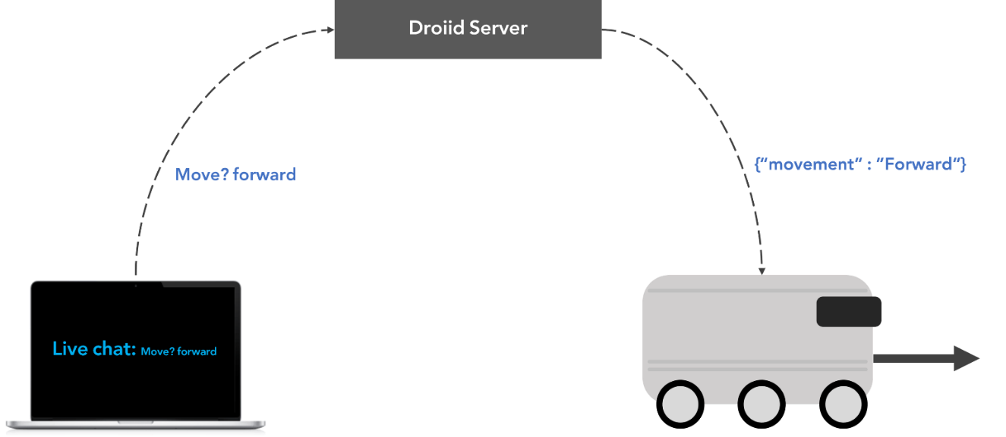

Figure 4 showcasing Droiid

**2.8 THEORETICAL BACKGROUND AND ANALYSIS**

In this section, the iterative, creative, decision-making process in which the basic sciences, mathematics, and engineering sciences are applied to convert resources into solutions is to be demonstrated. A complete theoretical analysis of the proposed solution is to be given where equations, calculations, etc., are clearly explained before alternative solutions are suggested.

* 1. **Analyzing Alternative SOLUTIONs**

**2.9.1-Morphological chart**

|  |  |  |  |  |  |
| --- | --- | --- | --- | --- | --- |
| **Function** | **Means** | | | | |
| **1** | **2** | **3** | **4** | **5** |
| 1. Traversal of the campus | Wheels | Propellers | Continuous wheel track | Quadruped/Biped | Conveyer belt |
| 2. Carrying the package | Wagon | Carried Box | Pneumatic tubes |  |  |
| 3. Navigation | GPS | Predefined path | Pilotage [i] |  |  |
| 4. Maintain the safety of the package | Digital lock | Combination Lock | 2-step verification |  |  |
| **Feature** | **Means** | | | | |
| **1** | **2** | **3** | **4** | **5** |
| 1. Fast | Motors power | Mechanic | Lightweight |  |  |
| 2. Long battery life | Energy consumption | Capacity | Recharge time |  |  |

*Table 1 - Morphological chart*

[i] navigating by reference to visible landmarks

* **Alterative A:** Quadruped robot with a wagon attached to it, navigates using pilotage, the packages are secured using a 2-step verification system (2FA)
* **Alternative B**: Conveyer belt where the packages are put in a plastic box and placed on it, the conveyer belt spans the campus on a predefined path, the packages are secured using a combination lock.
* **Alternative C**: Ground robot that uses wheels to traverse the campus, the package is loaded on the robot (carried box), it navigates using GPS, the packages are secured using a Digital lock

Ideas from initial brainstorming:

* **Alternative D:** Robot Train
* **Alternative E:** Pneumatic System
* **Alternative F:** Drone delivery

# Alternative analysis

* 1. Ground Robot

A ground robot with a built-in storage cart uses four wheels to move between buildings within the university campus. The robot needs to be able move safely using obstacle avoidance techniques to avoid objects around it. It uses battery, to supply enough power for a complete back and forth trip. To be able to move between buildings, the ground robot needs a navigation algorithm to guide the robot through the whole trip.

**Pros:**

* Dynamic stop points
* Flexible pathfinding
* Doesn’t require special roads
* Moderate complexity

**Cons:**

* Requires obstacle avoidance algorithms
* Higher probability of getting stuck
* Easily tampered with
* Training phase is required

Movement

Batteries

Controller

Motors

Rear wheels

F

Kinetic ergy

Commands

Power

Heat

Sound



Figure 16 - Ground Robot’s glass box

Cost analysis

|  |  |  |  |
| --- | --- | --- | --- |
| **ITEM** | Expected Price | Quantity | Total |
|  |
| Jetson nano | $75.00 | 1 | $75.00 |  |
| Stereo Camera Module Compatible with Jetson Nano | $45.00 | 1 | $45.00 |  |
| Motor driver | $12.00 | 4 | $48.00 |  |
| Platform | $100.00 | 1 | $100.00 |  |
| Battery | $20.00 | 1 | $20.00 |  |
| Wheels | $12.00 | 4 | $48.00 |  |
| Motors | $15.00 | 4 | $60.00 |  |
| Total cost |  |  | $336.00 |  |

*Table 3 – Cost analysis for ground robot*

* 1. RoboDog

This alternative is a quadruped robot. It uses two front legs and two hind legs to move just like an animal would. Furthermore, it can traverse at acceptable speeds and carry a heavy load. This alternative can also walk on the campus and roads.

Pros:

1. Innovative
2. Can climb stairs
3. Can drag or carry the packages

Cons:

1. Complex
2. Easily tampered with (pushing, vandalizing, etc…).



Figure 3 – RoboDog’s Glass box

|  |  |  |  |
| --- | --- | --- | --- |
| **ITEM** | Expected Price | Quantity | Total |
|  |
| Jetson nano | $75.00 | 1 | $75.00 |  |
| Stereo Camera Module Compatible with Jetson Nano | $45.00 | 1 | $45.00 |  |
| LIDAR sensor | $100.00 | 1 | $100.00 |  |
| Gyroscope sensor | $15.00 | 1 | $15.00 |  |
| Wagon | $60.00 | 1 | $60.00 |  |
| Battery | $20.00 | 1 | $20.00 |  |
| Artificial limbs (3D printed) | $40.00 | 2 | $80.00 |  |
| Servo motors | $20.00 | 8 | $160.00 |  |
| Total cost |  |  | $555.00 |  |

Cost analysis

*Table 4 – Cost analysis for RoboDog*

* 1. Robot train tracks

To be able to use a mini train within campus, we need train tracks that connect the buildings we want to deliver to and from. By having different stops at different faculty buildings, and smart train junctions that can save time by switching to shorter routes the user can drop off the packages at 1 of the stops and then the receiver would take the package at the stop nearest to him/her.

Pros

* Eliminates the need for navigation algorithms.
* If pedestrians avoid the tracks, no need for obstacle avoidance.
* Can be fast

Cons

* Requires train tracks to function.
* Sub-optimal routes
* Limited to set of stops

Figure 4 - Robot train’s Glass box

Heat

Batteries

Controller

Train Tracks

Motors

Train

Power

Kinetic energy

Information

Power

Deliver packages

Sound



Cost analysis

Cost analysis

|  |  |  |  |
| --- | --- | --- | --- |
| **ITEM** | Expected Price | Quantity | Total |
|  |
| Arduino uno | $40.00 | 1 | $40.00 |  |
| Wagon | $60.00 | 3 | $180.00 |  |
| Battery | $20.00 | 1 | $20.00 |  |
| Traction motor | $450.00 | 1 | $450.00 |  |
| Total cost |  |  | $690.00 |  |

*Table 5 – Cost analysis for Robot Train*

# Choosing Baseline Design

Table 6 - KTDA Table

|  |  |  |  |  |  |  |
| --- | --- | --- | --- | --- | --- | --- |
| Musts/Alternatives | A: Quadruped Robot | B: Conveyer Belt | C: Ground Robot | D: Robot Train | E: Pneumatic tube system | F: Drone |
| The ability to move within 2 km range of the Engineering building | GO |  | GO | GO |  |  |
| Ensures the safety of the packages. | GO | GO | GO | GO | GO | GO |
| Includes a storage unit for the shipments. | GO | GO | GO | GO | GO | GO |
| Tamper proof electronic components | GO | GO | GO | GO | GO | GO |
| Made from durable material. | GO | GO | GO | GO | GO | GO |
| Operate within 5 km/h. | GO | NO GO | GO | GO | GO | GO |
| Can carry weight within (80kg). | GO |  | GO | GO | NO GO | NO GO |
| Constraints |  |  |  |  |  |  |
| The cost of the project must not exceed 5000 SAR. | GO |  | GO | GO |  |  |
| Project must be completed before the end of Term-2. | GO |  | GO | GO |  |  |
| Causes no harm to the surroundings. | GO |  | GO | GO |  |  |
| Battery life lasts for at least one complete trip (2 km). | GO |  | GO | GO |  |  |
| Guarantees the privacy of the packages. | GO |  | GO | GO |  |  |
| The artifact should withstand normal heat (36° C) for the duration of the trip (2 km) | GO |  | GO | GO |  |  |

After analyzing the alternatives, we chose the **Ground Robot** to be our baseline design. Due to it having the lowest cost, balanced complexity, and the availability of the parts. We modeled our idea using SolidWorks to be able to imagine our baseline design.



Figure 18 - SolidWorks model

**2.10 maturing baseline design**

To further improve our base model, we started thinking of things we could change. We thought of reusing a hoverboard instead of buying the different motors and motor drivers. Hoverboards contain powerful motors that could carry people (~100 kg) which makes the design sturdier. Furthermore, wheel encoders are included in the hoverboard eliminating the need to buy them. In addition to that, the hoverboards have a recharging capability that is simple to use. We also thought of adding ventilation slits to the wagon to improve thermal dissipation. In addition to that, one idea was to add a hole in the wagon for cable management to eliminate the possibility of unwanted friction of the wires with the ground.

**Chapter – 3 PRODUCT BASELINE DESIGN**

**3.1 Block diagram**

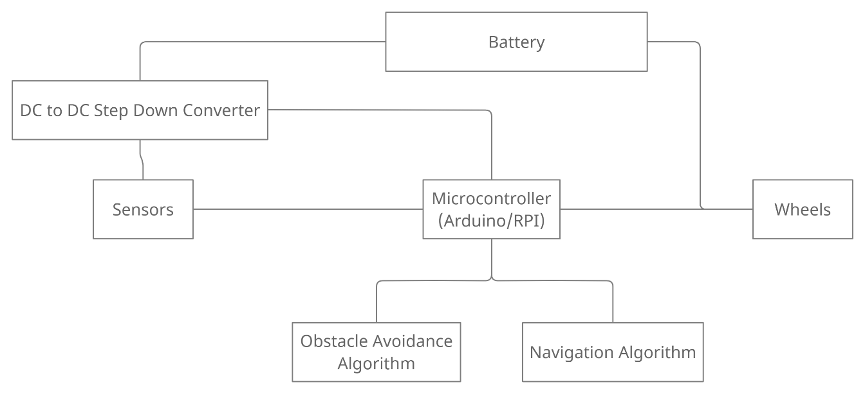

Figure 5 Block Diagram

**3.2 System descritpion**

***3.2.1 Circuit schematics***

***3.2.2 Circuit component specifications***

|  |  |
| --- | --- |
| **Component** | **Specifications** |
| **Jetson Nano** | **Manufacturer:** Nvidia  **GPU:** 128-core NVIDIA Maxwell  **CPU:** Quad-core ARM® A57  **Memory:** 2 GB 64-bit  **Module Size:** 70mm x 45mm |
| **NodeMCU ESP8266** | **Microcontroller:** ESP-8266 32-bit  **Module Size:** 49mm x 26mm  **Clock speed:** 80 MHz  **Operating Voltage:** 3.3V  **Input voltage:** 4.5V-10V  **SRAM:** 4 MB / 64 KB  **Digital Pins:** 11  **Analog Pins:** 1  **Built-in Wi-Fi:** 802.11 b/g/n  **Temperature range:** -40C - 125C |
| **IMX219-83 8MP 3D Stereo Camera Module** | **Megapixels:** 8 Megapixels  **Resolution:** 3280 × 2464 (per camera)  **Dimensions:** 24mm × 85mm  **Gyroscope Operating Current:** 1.23mA  **Angle of View:** 83/73/50 degree (diagonal/horizontal/vertical) |
| **dc-to-dc convertor 12v to 5v** | **Manufacturer:** Chuanguifa  **Type:** step down dc-to-dc convertor  **Input voltage:** 12V  **Output Voltage:** 5V  **Output current:**3A  **Output power:**15W  **Efficiency:** ＞96%  **Operating temperature:** (-40°, 80°)  **Size:** 45x26x12 (mm) |
| **Rechargeable battery** | **Voltage:** 36 V  **Discharge Current:** 75A  **Dimensions:** 101mm x 90mm x 70mm  **Weight:** 1.62 Kg  **Internal Resistance at 1KHz:** 34 mΩ |
| **Motors** | **Manufacturer:** huhu  **Speed:** 100 RPM  **Operating voltage:** 36 volts  **Torque:** 10 Kg.cm  **Weight:** 158.75 g |

***3.2.3 Flowcharts for software blocks***

## **Navigation Flow Chart**

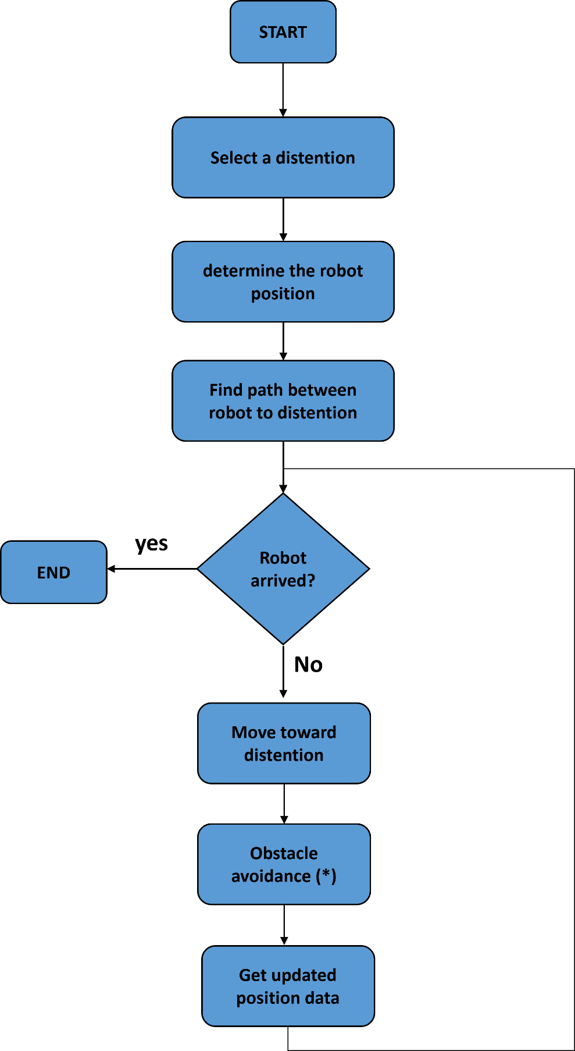

## **Obstacle avoidance flow chart**

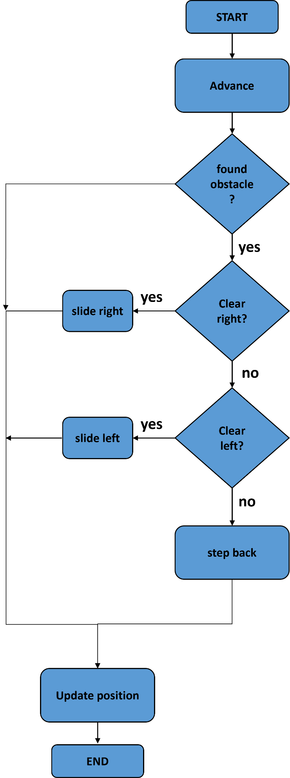

***3.2.4 Mechanical specifications of the case***

This section should may 3D projection drawings, dimensions, weight, etc.

***3.2.5 Possible aesthetics***

Aesthetics are an important part to make the user feel more connected to the robot. There are two main aesthetical changes that would be beautiful if applied to the artifact. First, stickers that can be applied to the robot with the logo of KAU and Engineering Faculty. These stickers can be applied to the sides of the platform to showcase that the robot is from the students of the faculty. This in turn may help the users feel a sense of home.

Another beautification idea is painting the robot white in color. This can allow the robot to be seen clearly from far away which can help people recognize the robot. Even though the robot might not need this, it helps promote a beauty aspect in robots.



Figure 2 Logos

.

***3.2.6 Input/output specifications***

An AC input power source of 220Vac with 60Hz frequency, single phase is needed to supply the battery with charging power. Max input current is 2A current with max power consumption of 440W.

***3.2.7 Operating Instructions***

Operation of the robot is very simple; any layman can use it without issue.

1. Locate the robot within a stop point.
2. Place shipment/package inside the luggage compartment.
3. Open the robot UI using any smart device.
4. Enter destination for the shipment and receiver details.
5. Enter lock **#** for security.
6. Press Start.
7. Wait for confirmation from receiver. (done)

**3.3 Simulation results**

Software simulation of the design of any block is recommended but not required.